12/06/2025, Legacy (last week)

https://www.youtube.com/live/zrBbHGOHFU8?si=Ia0051qwh1wC74yC

“Come All Ye Hopeless | Come All Ye Faithless,” Dr. Jo Vitale



“Ye” = “y’all.” The phrase

1. "Come All Ye Hopeless" means “All of you who are without hope, come here".

2. "Come All Ye Faithless" means “All of you who are without faith, come here".

Introduction:

10:00/1:15:03

 

21:35/1:15:03

 

Phil EuBank, Lead Pastor

 

Dr. Jo Vitale

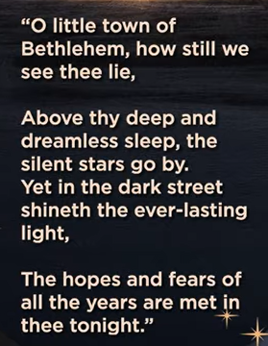

O little town of Bethlehem, how still we see thee (you) lie, Above thy (your) deep and dreamless sleep, the silent stars go by. Yet in the dark street shineth (old word of “shines”) the ever-lasting light.

This is a beautiful and famous stanza (standing place) from the classic Christmas hymn (religious song), "O Little Town of Bethlehem," written by Phillips Brooks in 1867, describing how the divine "everlasting Light" (Jesus Christ) breaks the darkness of the world, fulfilling hopes and fears. It captures the quiet, sleepy nature of the town contrasted with the profound spiritual event happening within its "deep and dreamless sleep," with silent stars watching over.

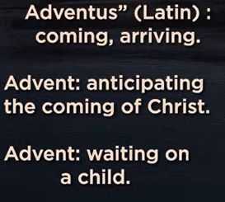

Adventus (Latin): coming, arriving

Advent: Anticipating the coming of Christ

Advent: Waiting on a Child

Advent is a Christian liturgical season of four weeks focusing on **anticipation and preparation for Christ's coming**, commemorating His birth (first coming) and looking forward to His return (second coming), teaching believers patient, hopeful waiting, much like the Old Testament figures awaited the Messiah, fostering a spirit of reflection, hope, peace, joy, and love, especially through waiting for the promised Child. It's a time of "expectant waiting," learning to trust God's plan even in personal struggles or delays, finding deeper meaning in the promise of the Savior's arrival, says [this article from Sharla Fritz](https://sharlafritz.com/2019/12/advent-waiting-waiting-without-preconceptions/).

**Key Aspects of Advent Waiting**

* **Dual Anticipation:** We wait for Jesus' birth (past) and His glorious return (future), embracing a broader sense of waiting for God to make things right.
* **Hopeful & Purposeful:** It's not impatient waiting, but a hopeful, joyous anticipation, learning lessons of delayed gratification and building excitement for the good things to come, as explained in this blog post from U.S. Catholic.
* **Spiritual Preparation:** It involves preparing hearts and minds through prayer, scripture (Isaiah, prophecies of Immanuel), and reflection on themes like hope, peace, joy, and love, notes [this Facebook post](https://www.facebook.com/sarahkrogermusic/posts/the-word-advent-means-arrival-and-for-us-its-a-season-of-preparing-and-waiting-f/1573026494827081/).
* **Waiting on the Child:** This focuses on the Incarnation—God coming in human flesh as a baby—and learning to trust the unfolding divine plan, even when personal expectations aren't met, says [this piece from Rare Mamas by Nikki McIntosh](https://raremamas.com/advent-a-season-of-waiting-anticipating/).

**How it Connects to "Waiting on a Child"**

* **Learning from the Figures:** Just as figures like Anna waited for the Messiah in the Temple (Luke 2:25-38), Advent invites us to wait with patience, letting go of our own timelines and trusting God's timing, as Sharla Fritz explains.
* **Embracing the "Delay":** The waiting period teaches us to find God's presence *now*, even while anticipating the future, fostering resilience and deeper faith in His goodness, notes [this article from My Catholic Kids](https://mycatholickids.com/season-advent-waiting-hope/).
* **Childlike Wonder:** It reconnects us with the wonder of a child's anticipation for Christmas, building enthusiasm for the "greatest gift" that arrived in the form of a helpless baby, according to [the Archdiocese of San Francisco](https://sfarch.org/advent-wonder-ful-waiting/).

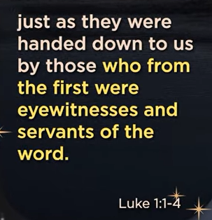 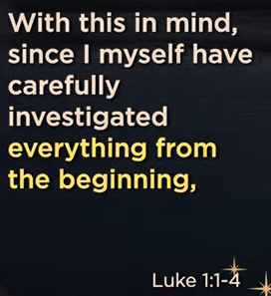 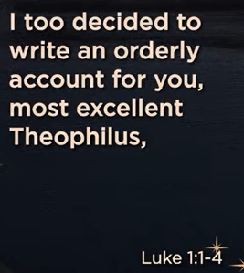 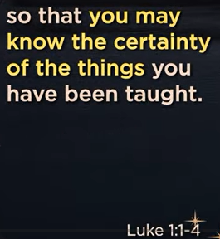

Luke 1:1-4

**Dedication to Theophilus**

**1**Inasmuch as many have undertaken to compile a narrative of the things that have been accomplished among us, **2**just as those who from the beginning were eyewitnesses and ministers of the word have delivered them to us, **3**it seemed good to me also, having followed all things closely for some time past, to write an orderly account for you, most excellent Theophilus, **4**that you may have certainty concerning the things you have been taught.

The main point of Luke 1:1-4 is to introduce the Gospel's purpose: to provide an **orderly, historically reliable account** of Jesus's life, based on **eyewitness testimonies**, for a man named Theophilus, ensuring he understands the truth and certainty of the events surrounding Jesus, fulfilling God's plan. Luke emphasizes that his narrative is meticulously researched, drawing from original witnesses, to build confidence in the Gospel story as factual history, not myth.

Here's a breakdown of the key themes:

* **Reliability & History:** Luke presents himself as a careful historian, compiling facts from those who were there from the beginning (eyewitnesses and ministers of the word).
* **Fulfillment of God's Plan:** The events described are not random but are the "things which have been fulfilled among us," pointing to God's unfolding purpose.
* **Purpose for Theophilus (and us):** To give Theophilus (and readers) a firm grasp of the truth about Jesus, to know how God saves people from sin, and to inspire confidence in these foundational beliefs.
* **Authoritative Source:** By relying on eyewitnesses, Luke legitimizes his account, showing it's based on firsthand accounts, not just hearsay.

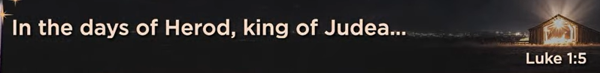

Luke 1:5

**Birth of John the Baptist Foretold**

**5**In the days of Herod, king of Judea, there was a priest named Zechariah,[[a](https://www.biblegateway.com/passage/?search=Luke%201%3A5&version=ESV#fen-ESV-24890a)] of the division of Abijah. And he had a wife from the daughters of Aaron, and her name was Elizabeth.

The main point of Luke 1:5 is to set the historical stage for the miraculous birth of John the Baptist, introducing his parents, Zechariah and Elizabeth, as righteous individuals living in the days of [King Herod](https://www.google.com/search?q=King+Herod&rlz=1C1KDEC_enUS826US826&oq=main+point+of+luke+1%3A5&gs_lcrp=EgZjaHJvbWUyBggAEEUYOdIBCDQ2OTBqMGo0qAIAsAIB&sourceid=chrome&ie=UTF-8&mstk=AUtExfBcWSvvrzORryqjb5b9k02zNhlXxObhmeUVqpUt5zxbxli9FMGVNfzeU5fAUMx1C1TBwdGN01B-v_S7rfNGZIvmo3Uf1dyxJrweq5rkWqQxVqXP2cLFXlVar7oRrIv6etrk3GpgR4zUzWRmOQl4VpBA4disQKZQAciNwD8ldHHv8CZ9CAof_W94uCep-1l0rrGzJIKTtL_89X6Nfy_yW__nQfT3FhohdU-vKAesrwnYgC7zMlrdM60TJ2lGriZFs7lrDs0GTn5UtNRVHAR1z0fl&csui=3&ved=2ahUKEwiEh7Ok2KqRAxWDOzQIHeKCImgQgK4QegQIARAC), highlighting God's faithfulness to bless the faithful even after long periods of barrenness and prophetic silence, signaling the beginning of God's new work in fulfilling His promises through unexpected people.

**Key Aspects of Luke 1:5:**

* **Historical Context:** It places the event in the reign of King Herod, grounding the story in real history.
* **Introduction of Zechariah & Elizabeth:** They are presented as devout, elderly, and righteous, but childless, reflecting Israel's long wait for the Messiah.
* **Symbolism of Barrenness:** Elizabeth's barrenness mirrors Israel's spiritual barrenness and prophetic silence, making the coming child a sign of God remembering His promises.
* **Setting the Scene for Miracles:** This verse introduces the characters and circumstances that will soon be interrupted by the angel Gabriel, preparing the reader for the extraordinary events to follow.
* **Theme of God's Sovereignty:** It establishes that God works through ordinary, humble people to bring about His extraordinary purposes, fulfilling His divine plan.

In essence, Luke 1:5 is the opening note that says, "God's story of salvation is continuing, even in seemingly quiet and barren times, through faithful people like Zechariah and Elizabeth".

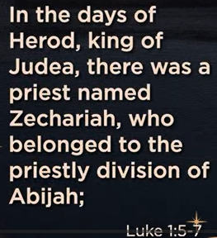 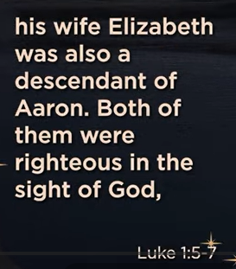 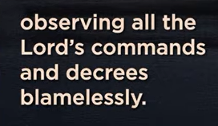 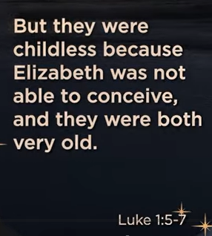 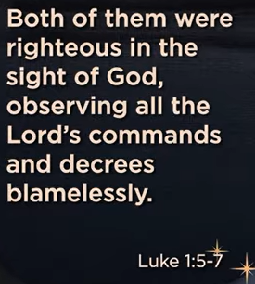

Luke 1:5-7

English Standard Version

**Birth of John the Baptist Foretold**

**5**In the days of Herod, king of Judea, there was a priest named Zechariah,[[a](https://www.biblegateway.com/passage/?search=Luke%201%3A5-7&version=ESV#fen-ESV-24890a)] of the division of Abijah. And he had a wife from the daughters of Aaron, and her name was Elizabeth. **6**And they were both righteous before God, walking blamelessly in all the commandments and statutes of the Lord. **7**But they had no child, because Elizabeth was barren, and both were advanced in years.

The main point of Luke 1:5-7 introduces Zechariah and Elizabeth, a righteous, elderly, and barren priestly couple during King Herod's reign, setting the stage for God to miraculously intervene and grant them a son (John the Baptist) to prepare the way for the Messiah, showing God works through seemingly hopeless situations to fulfill His promises.

**Key elements:**

* **Setting the Scene:** The passage grounds the story in history ("in the days of Herod") and introduces godly, obedient people (Zechariah, a priest, and his wife Elizabeth).
* **The Problem:** Despite their righteousness, they are childless and advanced in years, a source of shame in their culture, making a child seem impossible.
* **Divine Intervention:** This seemingly hopeless situation highlights God's power to bring about the miraculous, as He would soon reveal through an angel.
* **Foreshadowing:** It establishes the context for the first miraculous birth (John the Baptist) that precedes Jesus' own miraculous birth, demonstrating God's faithfulness and plan.

In essence, Luke 1:5-7 shows God choosing a faithful, but barren, couple to begin His world-changing work, emphasizing that God often uses the unlikely to accomplish His divine purposes.

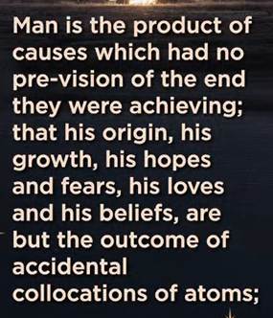 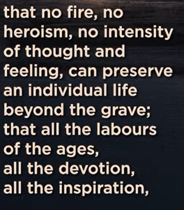 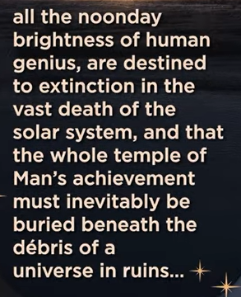 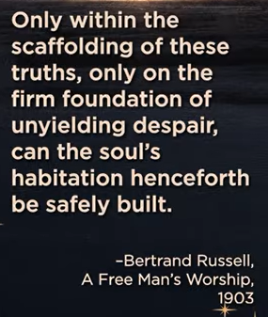

Bertrand Russell, A Free Man’s Worship (1903):

Man is the product of causes which had no prevision of the end they were achieving; that his origin, his growth, his loves, and his beliefs, are but the outcome of accidental collocations of atoms; that no fire, no heroism, no intensity of thought and feeling, can preserve an individual life beyond the gravel that all the labor of the ages, all the devotion, all the inspiration, all the noonday brightness of human genius, are destined to extinction in the vast death of the solar system, and that the whole temple of man’s achievement must inevitably be buried beneath the debris of a universe in ruins… Only within the scaffolding of these truths, only on the firm founding of unyielding despair, can the soul’s habitation henceforth be safely built.

Bertrand Russell's "[A Free Man’s Worship](https://www.google.com/search?q=A+Free+Man%E2%80%99s+Worship&kgmid=/m/06bkg8v&sa=X&ved=2ahUKEwjX-vGz3KqRAxUADTQIHU9RA0wQ3egRegQIARAC)" argues for **building one's moral framework and life's meaning upon the stark reality of a purposeless and indifferent universe**. This philosophy, which he terms the "firm founding of unyielding despair," is the acknowledgment of humanity's impermanence and the universe's ultimate power.

**Explanation**

Russell contends that science reveals a world without inherent purpose or design.

* **Humanity's origin** is merely an "outcome of accidental collocations of atoms".
* **Individual life** is transient, with no afterlife to preserve it beyond the grave.
* **All human achievements** and aspirations are ultimately "destined to extinction" with the death of the solar system.

Accepting these "truths" is not a call for inaction but a necessary first step toward true freedom and moral action. The "free man" does not submit to the "tyranny that rules his outward life" but instead builds a spiritual or moral "habitation" based on his own ideals of goodness and beauty, rather than on false hope or the worship of power. This approach allows one to preserve a mind free from the "coward terrors of the slave of Fate" and to act with a noble, though weary, courage in the face of an indifferent universe.

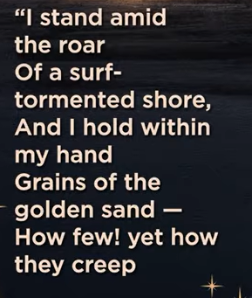 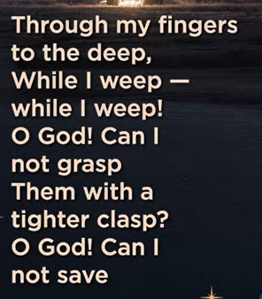 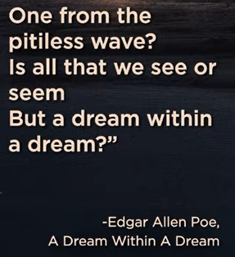

A Dream Within A Dream, by Edgar Allen Poe (1849):

I stand amid the roar of a surf-tormented shore, and I hold within my hand grains of golden sand – How few! Yet how they creep through my fingers to the deep, while I weep – while I weep! O God! Can I not grasp them with a tighter clasp? O God! Can I not save one from the pitiless wave? Is all the we see or seem but a dream withing a dream?

A Dream Within A Dream, by Edgar Allan Poe's poem, which captures the narrator's profound existential despair and sense of powerlessness as time and reality slip away like "golden sand" through his fingers, questioning if anything real can truly be grasped or saved from the inevitable "pitiless wave" of existence. This famous section highlights the poem's themes of disillusionment, mortality, and the blurred line between waking life and dreams, suggesting everything we perceive might just be an illusion within a greater illusion.

**Key Interpretations:**

* **Mortality & Time:** The "golden sand" often symbolizes fleeting time or lost loved ones, which the narrator desperately tries to hold onto but fails.
* **Existential Doubt:** The repeated question, "Is all that I see or seem / But a dream within a dream?" reflects a deep crisis, questioning the very nature of reality.
* **Powerlessness:** The anguished cries to God ("O God! can I not grasp them with a tighter clasp?") underscore the human inability to control fate or stop loss.

This stanza encapsulates Poe's characteristic melancholy and his exploration of the darker aspects of the human condition, making it one of his most memorable passages.

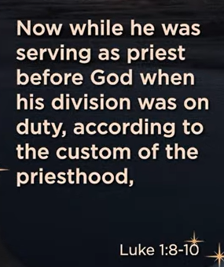 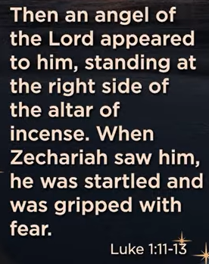 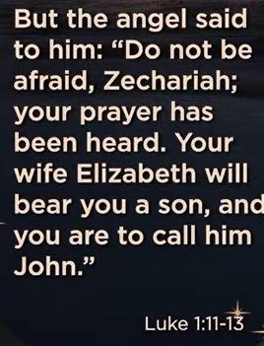

Luke 1:8-10

English Standard Version

**8**Now while he was serving as priest before God when his division was on duty, **9**according to the custom of the priesthood, he was chosen by lot to enter the temple of the Lord and burn incense. **10**And the whole multitude of the people were praying outside at the hour of incense.

The main point of Luke 1:8-10 is to set the scene for a pivotal moment in the temple: [**Priest Zechariah**](https://www.google.com/search?q=Priest+Zechariah&rlz=1C1KDEC_enUS826US826&oq=main+point+of+Luke+1%3A8-10&gs_lcrp=EgZjaHJvbWUyBggAEEUYOdIBCDM2MjZqMGo0qAIAsAIB&sourceid=chrome&ie=UTF-8&mstk=AUtExfAsb9eQJjO1TJj3kmhbMu611WYDtn4N3hvn7_YB0FL05y-k_ZNwl5h0b9Q-kS1c4cGTitNpteiAk8uokaCMqr6rsfE_lK6kItC09XiHZf6NOwczbpw0o7_vYWYfAdg1KW3_V44JDEyYONk3FBnYUTNT-bPrMkOxr6wWWksqkKWftKRTGzmjnC7gkmO662_GYGokBCSJtmlESKs68yQfZR6FTu0VAqLbgnJk_2o8g3rZ3L1-ipgBfDx5CjSSuAp_BiQurmMrh1Sw4w6MGtuVKq_jS_1VRObkvdB-vna-eUs0BcvcGgmVrneBtF8__JrCh35n7cWuTVUi1Gv6poiNI-x8N4GNi0HTP4R5NEa-HHiA&csui=3&ved=2ahUKEwi1vfjv4KqRAxWeODQIHVc2EUAQgK4QegQIARAC) (father of John the Baptist) was chosen by lot for the rare honor of burning incense, a sacred duty where a great crowd of worshipers was praying outside, connecting the symbolic offering of incense with the people's prayers to God. This highlights themes of faithful temple service, divine appointment through lots, and the anticipation of God answering prayers, setting the stage for the angel's appearance in the next verses.

**Key Elements:**

* **Zechariah's Duty:** As part of his priestly division (Abijah), Zechariah was selected by lot (a random draw) to perform the highly significant act of burning incense in the Lord's sanctuary.
* **Temple Setting:** This was a special occasion, as such a chance to burn incense might only happen once in a priest's lifetime.
* **Worship & Prayer:** While Zechariah was inside, a large congregation of people were praying outside, linking the ritual with the collective prayers of the people.
* **Symbolism:** The burning of incense often symbolized the prayers of God's people rising to heaven (Revelation 5:8).

**Significance:**  
This passage establishes the ordinary, devout life of Zechariah and Elizabeth, only to be interrupted by God's extraordinary plan, foreshadowing the arrival of the Messiah through John the Baptist.

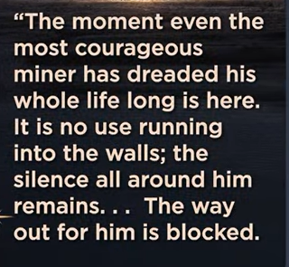 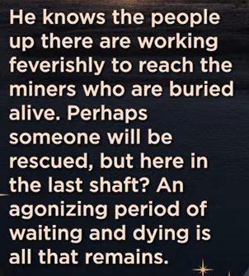 

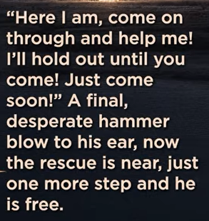 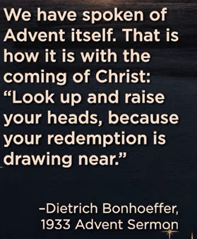

1933 Advent Sermon, by Dietrich Bonhoeffer:

The moment even the most courageous miner has dreaded his whole life long is here. It is no use running into the walls; the silence all around him remains… The way out for him is blocked.

He knows the people up there to reach the miners who are buried alive, Perhaps someone will be rescued but here in the last shaft? An agonizing period of waiting and dying is all that remains, But suddenly, a noise that d=sounds like tapping and breaking in the rock can be heard. Unexpectedly, voices cry out, “Where are you, help is on the way!” Then the disheartened miner pick himself up, his heart leaps, he shouts.

“Here I am, come on through and help me! I’ll hold out until you come! Just come soon!” A final, desperate hammer blow to his ear, now the rescue is near, just one more step and he is free.

We have spoken of Advent itself, That is how it is with the coming of Christ: “Look up and raise your heads, because your redemption is drawing near.”

1933 Advent sermon by Dietrich Bonhoeffer, where he uses the vivid analogy of trapped **miners waiting for rescue** to illustrate the Christian experience of **Advent as a period of hopeful waiting for Christ's coming and redemption**.

**Explanation**

* The sermon uses the contemporary image of a mine disaster and the desperate, yet hopeful, wait of a buried miner for the sounds of rescue. This scenario of being trapped in darkness and despair mirrors the human condition before the arrival of a Savior.
* The sudden noise of tapping and the cry, "Where are you, help is on the way!" symbolizes the unexpected, miraculous intervention of God in the world.
* The final line, referencing Luke 21:28, "Look up and raise your heads, because your redemption is drawing near," directly ties the miner's hope for physical rescue to the spiritual hope of **redemption** brought by Christ's advent.
* Bonhoeffer preached this sermon in London just as the Nazi regime was consolidating power in Germany, adding a layer of contemporary political darkness to the spiritual message of hope and deliverance.

This analogy teaches that Advent is not a passive waiting but a time of alert anticipation and faith, even in the bleakest circumstances, because the promise of salvation is real and approaching.



Pizzeria LUCCA, Brick Oven near Italians Pizza

Pizzeria Lucca refers the real Italian Pizza with high heat (900-degree F) with Brick Oven in Roswell, GA.



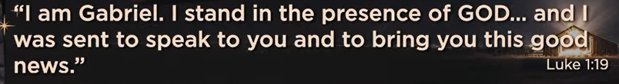

Luke 1:18-19

English Standard Version

**18**And Zechariah said to the angel, “How shall I know this? For I am an old man, and my wife is advanced in years.” **19**And the angel answered him, “I am Gabriel. I stand in the presence of God, and I was sent to speak to you and to bring you this good news.

The main point of Luke 1:18-19 is the **contrast between human doubt and divine promise**, as Zechariah questions the angel Gabriel about having a son in old age, highlighting the miraculous nature of God's plan and setting up the theme that God's power overcomes human limitations, foreshadowing John the Baptist's birth and Jesus's virgin birth, according to [Bible Hub](https://biblehub.com/luke/1-18.htm), [BibleRef.com](https://www.bibleref.com/Luke/1/Luke-1-18.html), and [The Bible Says](https://thebiblesays.com/en/commentary/luk+1:18).

**Key Aspects of Luke 1:18-19:**

* [**Zechariah's Doubt**](https://www.google.com/search?q=Zechariah%27s+Doubt&rlz=1C1KDEC_enUS826US826&oq=amin+point+of+Luke+1%3A18-19&gs_lcrp=EgZjaHJvbWUyBggAEEUYOdIBCDc5MTVqMGo0qAIAsAIA&sourceid=chrome&ie=UTF-8&mstk=AUtExfCy49WoFPZFX_eByAe2ir9qJYKPJepiqdAMpZW-P51NPcEnv41XMI0c5i1R_XRHHWczvC8obTOyFzcHAEj98ID-WTg5LtTGl9Ct7xKetU-xb5Wlv4IEMkh28Si0DogcbNi3JmdUOjCEChEnC4rk5Mu8ZlUS62lmzv-HrE3-MTQTnEOmZsJ66_PFRXKhak3xV5Ae5vf8foE7WDgI2GRLEMnIADhlEYhBWta9If5DrhkSIpTQ8OHUXLtX-iIU2aKEMB7wvykUiGAy10RQNkU1kx0LRU1i3naqQMlD-BkNOnIuRMaLYyuVl6D8Rr5pz5JQFcvAgsXfuPWhXc1aat3_EjUJJTrIXKUBwfDHD1lTrBYM4bXTrgNtMCNjOSc9rYUbJQ&csui=3&ved=2ahUKEwiExdLe66qRAxXLyOYEHQ_8E70QgK4QegQIAxAB)**:** As a righteous priest, Zechariah expresses disbelief at the angel's message due to his and his wife Elizabeth's advanced age, asking for proof, notes BibleRef.com and [Bible Hub](https://biblehub.com/study/luke/1-18.htm).
* [**Gabriel's Authority**](https://www.google.com/search?q=Gabriel%27s+Authority&rlz=1C1KDEC_enUS826US826&oq=amin+point+of+Luke+1%3A18-19&gs_lcrp=EgZjaHJvbWUyBggAEEUYOdIBCDc5MTVqMGo0qAIAsAIA&sourceid=chrome&ie=UTF-8&mstk=AUtExfCy49WoFPZFX_eByAe2ir9qJYKPJepiqdAMpZW-P51NPcEnv41XMI0c5i1R_XRHHWczvC8obTOyFzcHAEj98ID-WTg5LtTGl9Ct7xKetU-xb5Wlv4IEMkh28Si0DogcbNi3JmdUOjCEChEnC4rk5Mu8ZlUS62lmzv-HrE3-MTQTnEOmZsJ66_PFRXKhak3xV5Ae5vf8foE7WDgI2GRLEMnIADhlEYhBWta9If5DrhkSIpTQ8OHUXLtX-iIU2aKEMB7wvykUiGAy10RQNkU1kx0LRU1i3naqQMlD-BkNOnIuRMaLYyuVl6D8Rr5pz5JQFcvAgsXfuPWhXc1aat3_EjUJJTrIXKUBwfDHD1lTrBYM4bXTrgNtMCNjOSc9rYUbJQ&csui=3&ved=2ahUKEwiExdLe66qRAxXLyOYEHQ_8E70QgK4QegQIAxAE)**:** The angel identifies himself as Gabriel, who "stands in the presence of God," emphasizing the divine source of the message, says [Biblia](https://biblia.com/bible/esv/luke/1/18-19) and The Bible Says.
* [**Theme of Miraculous Births**](https://www.google.com/search?q=Theme+of+Miraculous+Births&rlz=1C1KDEC_enUS826US826&oq=amin+point+of+Luke+1%3A18-19&gs_lcrp=EgZjaHJvbWUyBggAEEUYOdIBCDc5MTVqMGo0qAIAsAIA&sourceid=chrome&ie=UTF-8&mstk=AUtExfCy49WoFPZFX_eByAe2ir9qJYKPJepiqdAMpZW-P51NPcEnv41XMI0c5i1R_XRHHWczvC8obTOyFzcHAEj98ID-WTg5LtTGl9Ct7xKetU-xb5Wlv4IEMkh28Si0DogcbNi3JmdUOjCEChEnC4rk5Mu8ZlUS62lmzv-HrE3-MTQTnEOmZsJ66_PFRXKhak3xV5Ae5vf8foE7WDgI2GRLEMnIADhlEYhBWta9If5DrhkSIpTQ8OHUXLtX-iIU2aKEMB7wvykUiGAy10RQNkU1kx0LRU1i3naqQMlD-BkNOnIuRMaLYyuVl6D8Rr5pz5JQFcvAgsXfuPWhXc1aat3_EjUJJTrIXKUBwfDHD1lTrBYM4bXTrgNtMCNjOSc9rYUbJQ&csui=3&ved=2ahUKEwiExdLe66qRAxXLyOYEHQ_8E70QgK4QegQIAxAH)**:** Zechariah's situation echoes Old Testament stories (like Sarah, Abraham, Hannah), showing God's power to bring life where human ability fails, according to Bible Hub and Bible Hub.
* [**Foreshadowing**](https://www.google.com/search?q=Foreshadowing&rlz=1C1KDEC_enUS826US826&oq=amin+point+of+Luke+1%3A18-19&gs_lcrp=EgZjaHJvbWUyBggAEEUYOdIBCDc5MTVqMGo0qAIAsAIA&sourceid=chrome&ie=UTF-8&mstk=AUtExfCy49WoFPZFX_eByAe2ir9qJYKPJepiqdAMpZW-P51NPcEnv41XMI0c5i1R_XRHHWczvC8obTOyFzcHAEj98ID-WTg5LtTGl9Ct7xKetU-xb5Wlv4IEMkh28Si0DogcbNi3JmdUOjCEChEnC4rk5Mu8ZlUS62lmzv-HrE3-MTQTnEOmZsJ66_PFRXKhak3xV5Ae5vf8foE7WDgI2GRLEMnIADhlEYhBWta9If5DrhkSIpTQ8OHUXLtX-iIU2aKEMB7wvykUiGAy10RQNkU1kx0LRU1i3naqQMlD-BkNOnIuRMaLYyuVl6D8Rr5pz5JQFcvAgsXfuPWhXc1aat3_EjUJJTrIXKUBwfDHD1lTrBYM4bXTrgNtMCNjOSc9rYUbJQ&csui=3&ved=2ahUKEwiExdLe66qRAxXLyOYEHQ_8E70QgK4QegQIAxAJ)**:** This encounter sets the stage for the miraculous birth of John the Baptist, who will prepare the way for Jesus, writes Bible Hub.
* [**Consequence of Doubt**](https://www.google.com/search?q=Consequence+of+Doubt&rlz=1C1KDEC_enUS826US826&oq=amin+point+of+Luke+1%3A18-19&gs_lcrp=EgZjaHJvbWUyBggAEEUYOdIBCDc5MTVqMGo0qAIAsAIA&sourceid=chrome&ie=UTF-8&mstk=AUtExfCy49WoFPZFX_eByAe2ir9qJYKPJepiqdAMpZW-P51NPcEnv41XMI0c5i1R_XRHHWczvC8obTOyFzcHAEj98ID-WTg5LtTGl9Ct7xKetU-xb5Wlv4IEMkh28Si0DogcbNi3JmdUOjCEChEnC4rk5Mu8ZlUS62lmzv-HrE3-MTQTnEOmZsJ66_PFRXKhak3xV5Ae5vf8foE7WDgI2GRLEMnIADhlEYhBWta9If5DrhkSIpTQ8OHUXLtX-iIU2aKEMB7wvykUiGAy10RQNkU1kx0LRU1i3naqQMlD-BkNOnIuRMaLYyuVl6D8Rr5pz5JQFcvAgsXfuPWhXc1aat3_EjUJJTrIXKUBwfDHD1lTrBYM4bXTrgNtMCNjOSc9rYUbJQ&csui=3&ved=2ahUKEwiExdLe66qRAxXLyOYEHQ_8E70QgK4QegQIAxAL)**:** Zechariah's questioning leads to his temporary muteness as a sign, teaching him (and readers) about God's power and the importance of faith, notes [Bible Hub](https://biblehub.com/commentaries/luke/1-18.htm) and The Bible Says.

In essence, these verses show God sending His powerful messenger to announce a miraculous birth, met with human skepticism, and establishing a pattern for divine intervention and the need for faith, according to Bible Hub and BibleRef.com.

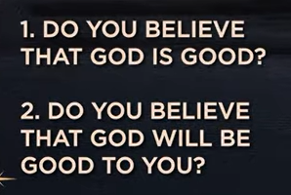

1. Do you believe that God is good?

2. Do you believe that God will be Good to You?

**"Do you believe that God will be Good to You?"**

* **Faith vs. Knowledge:** This moves from acknowledging God's existence (even demons believe this, [James 2:19](https://www.facebook.com/BrysonGrayOfficial/posts/james-219-20you-believe-that-god-is-one-you-do-well-the-demons-also-believe-and-/1124698725992679/)) to personal trust and action.
* **God's Promise:** God promises to work all things for the good of those who love Him and are called according to His purpose, working through difficulties to bring ultimate good, as discussed on Think Eternity and in this Strength for the Soul article.
* **Response to His Goodness:** It's a call to respond with trust, seeking Him and finding refuge in Him, trusting His perfect love and provision, [according to this FaithGateway post](https://faithgateway.com/blogs/christian-books/do-i-really-believe-god-is-good) and GotQuestions.org.
* **Gospel as Good News:** The ultimate demonstration of God's goodness is the redemptive plan through Jesus Christ, offering forgiveness and eternal life, notes GotQuestions.org.

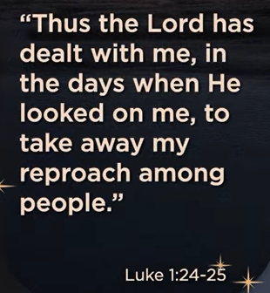

Luke 1:24-25

English Standard Version

**24**After these days his wife Elizabeth conceived, and for five months she kept herself hidden, saying, **25**“Thus the Lord has done for me in the days when he looked on me, to take away my reproach among people.”

In Luke 1:24-25, the main point is **Elizabeth's grateful acknowledgment that God has intervened to end her childlessness, thereby removing her social disgrace**. After conceiving, she secluded herself for five months, recognizing God's favor in her long-awaited pregnancy.

Key points from the verses:

* **Elizabeth Conceives:** Following the angel Gabriel's prophecy to her husband Zechariah (who was made temporarily mute because of his disbelief), Elizabeth becomes pregnant.
* **Seclusion:** She hides herself for five months, possibly for personal reflection, to savor the miracle privately, or to avoid public scrutiny until the pregnancy was established.
* **Removal of Disgrace:** Her main statement in the passage expresses profound relief and gratitude: "Thus the Lord has dealt with me in the days when he looked on me, to take away my reproach among people". In ancient society, barrenness was considered a significant social stigma and disgrace, and this pregnancy was a sign of God's direct intervention and kindness.

Essentially, the passage highlights God's faithfulness in answering prayers and intervening in human circumstances to fulfill His promises, specifically setting the stage for the birth of John the Baptist as a necessary precursor to Jesus Christ.

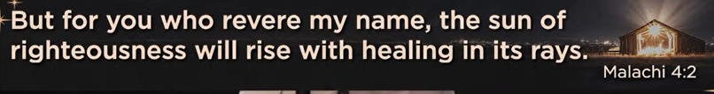

Malachi 4:2

English Standard Version

**2**But for you who fear my name, the sun of righteousness shall rise with healing in its wings. You shall go out leaping like calves from the stall.

The main point of Malachi 4:2 is a promise of **healing, restoration, and joyful freedom for those who revere God**, contrasting with the judgment of the wicked. It describes the "Sun of righteousness" (often interpreted as Jesus Christ) rising with "healing in its wings," bringing salvation and allowing the faithful to leap for joy, like calves released from a stall, signifying complete spiritual and physical renewal.

**Key Themes:**

* **Hope for the Faithful:** While the preceding verses speak of fiery judgment for the wicked, this verse offers hope for the righteous, who are characterized by their "fear" (reverence) for God's name.
* [**Messianic Prophecy**](https://www.google.com/search?q=Messianic+Prophecy&rlz=1C1KDEC_enUS826US826&oq=main+point+of+Malachi+4%3A2&gs_lcrp=EgZjaHJvbWUyBggAEEUYOdIBCDQ4OTJqMGo0qAIAsAIB&sourceid=chrome&ie=UTF-8&mstk=AUtExfDQ2l4lFaBbP2L92AulJiFbh6WzmZJRkTonnsoidrVsmbh-x1h8Gjx9AiAGDfLjbYJlzhXHHlTWkaux6yIe1-LXgH_5x9_93rx74pt10VK9cOVUDRwjDN0y8T6ZaWACtCDt0gnbr1m7IMJU9ZSkUUVa4xREV1VLcV4HUoI_8ezevLJ1Odqdy3AFKFI2VmvBMJxsQTz1OtjxBfWexrOboOmC4r4PYqW-PnnS4_jtp-CDBu-NfoX9LLC9PBcDgbHKnBB29RL8R3FPYw_x_3IPRd2RyMn013ZLL-S9vIXIp95qsFwiVtGHMp5-o8Ne5y3YPU5iiSdvZxo7D_gDGRgN9Cp1c8tf3iweMscHkr2nDCj7qJTMCx3Py4TQKZ9lCHOnEw&csui=3&ved=2ahUKEwjc0Ou97qqRAxUQFTQIHUIUI5wQgK4QegQIAxAC)**:** The "Sun of righteousness" is widely understood as a prophecy of the Messiah (Jesus), whose coming brings spiritual light, forgiveness, and healing to a world in darkness.
* **Healing & Wholeness:** "Healing in its wings" (or rays/edges) signifies God's restorative power, addressing both spiritual and physical wounds and bringing wholeness.
* **Joyful Freedom:** The imagery of "leaping like calves from the stall" conveys exuberant freedom and delight, a result of God's saving grace and presence.

In essence, Malachi 4:2 is a promise that God's coming judgment will ultimately distinguish the righteous from the wicked, bringing salvation, light, healing, and unbridled joy to those who honor Him, with Jesus Christ as the ultimate fulfillment of this promise.

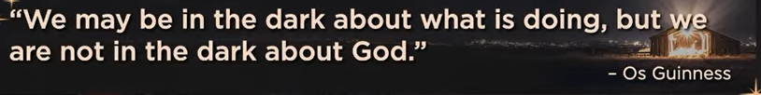

Os Guinness:

We may be in the dark about what is doing, but we are not the dark about God

Os Guinness's quote, "We may be in the dark about what God is *doing*, but we are not in the dark about God," means that while we often struggle to understand God's plan or purpose in difficult times (the "dark" situations), we can still know God's character and faithfulness through faith, as explored in his book *God in the Dark*, teaching that doubt isn't the enemy but an opportunity to know God more deeply, not blindly, but with examined assurance.

**Key Themes in the Quote**

* **"In the dark about what God is doing"**: Refers to human confusion and lack of understanding during trials, suffering, or unanswered prayers, where God seems silent or absent.
* **"Not in the dark about God"**: Highlights that our knowledge of God's unchanging nature (love, justice, presence) remains, even when His actions aren't clear.

**Context from His Book, *God in the Dark***

* **Doubt as a Pathway**: Guinness argues that doubt isn't unbelief but a serious engagement with faith, pushing us to examine and strengthen our understanding of God, not just leading to fear.
* **Examined Faith**: The goal isn't blind faith but an "examined faith" where we trust God's character and understand that faith is stronger for resolving doubts, not avoiding them.
* **Knowing God, Not Just His Plans**: The antidote to doubt involves returning to the basics, knowing God's faithfulness, and understanding He is present even in our darkest moments.

In essence, Guinness encourages believers to hold onto the knowledge of *who God is* when they can't grasp *what He's doing*, turning moments of darkness into deeper encounters with God's unchanging reality.

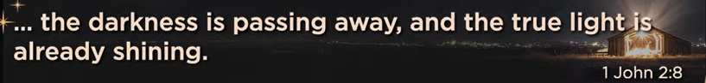

1 John 2:8

English Standard Version

**8**At the same time, it is a new commandment that I am writing to you, which is true in him and in you, because[[a](https://www.biblegateway.com/passage/?search=1%20John%202%3A8&version=ESV#fen-ESV-30542a)] the darkness is passing away and the true light is already shining.

The main point of 1 John 2:8 is that the "new commandment" to **love one another**, exemplified perfectly by Jesus, is both an old truth and a new reality for believers, because Christ's light has dawned, dispelling the darkness of the old way, and calls followers to live out this love as a sign of their transformation and new life in Him, [Bible Hub](https://biblehub.com/study/1_john/2-8.htm), [Bible Art](https://bible.art/meaning/1-john-2%3A8). It's a call to walk in the truth of God's light by actively demonstrating Christ-like love within the community, moving from spiritual darkness to spiritual light, Bible Hub, Bible Art.

**Key Concepts in 1 John 2:8:**

* **"Again, a new commandment I write to you"**: While love (loving your neighbor) is an ancient command, Jesus made it new through His life and teachings, [YouTube](https://www.youtube.com/watch?v=Epbi6lP0d_8).
* **"Which is true in Him and in you"**: This love is true in Jesus (His perfect example) and becomes true in believers as they follow Him, reflecting His light.
* **"Because the darkness is passing away and the true light now shines"**: The "darkness" (sin, ignorance, the old life) is receding as the "true light" (Christ and His truth) shines, bringing a new way of life characterized by love, Bible Art, Bible Hub.

In essence, 1 John 2:8 teaches that true faith in the light of Christ means living out the new, yet old, commandment of love for one another, which is a tangible sign of spiritual transformation, Bible Art, Bible Hub.

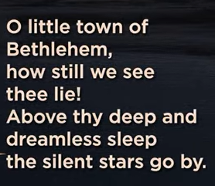 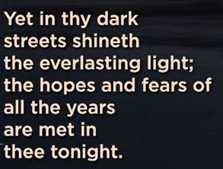 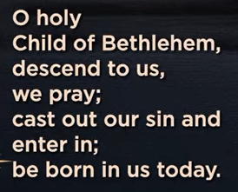 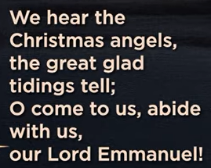

O little town of Bethlehem, how still we see thee (you) lie, Above thy (your) deep and dreamless sleep, the silent stars go by. Yet in the dark street shineth (old word of “shines”) the ever-lasting light; the hopes and fears of all the years are met in thee (you) tonight.

O holy, child of Bethlehem, descend to us, we pray; cast out our sin and enter in; be born in us today. We hear the Christmas angels; the great glad tidings tell; O come to us, abide with us, our Lord Emmanuel!

Christmas song “O Little Town of Bethlehem” by Phillip Brooks (1868), reflecting on the Nativity story where the "everlasting light" of Christ shines in the darkness, bringing hope and fulfilling ancient prophecies, inviting the holy child to be born in our hearts. The lyrics contrast the peaceful, silent town with the profound spiritual event, emphasizing Jesus as the promised Emmanuel (God with us) who offers salvation and peace, a beautiful message that continues to resonate today, especially in times of darkness.

**Key Themes & Meaning**

* **Quiet Hope:** The carol captures the stillness of Bethlehem but highlights the powerful spiritual significance, where "hopes and fears of all the years are met".
* **Light in Darkness:** "Shineth the everlasting Light" points to Jesus as the divine light entering a world of sin, offering hope and redemption, a common Christmas theme.
* **Personal Invitation:** The verses "Descend to us, we pray; cast out our sin and enter in; be born in us today" are a direct plea for spiritual renewal.
* **Emmanuel:** The final line, "O come to us, abide with us, our Lord Emmanuel!" invokes Jesus as "God with us," a central promise of Christmas.

**Origin**

* **Author:** Phillips Brooks, an Episcopal priest, wrote the poem after visiting Bethlehem in 1865, inspired by the quiet, holy atmosphere of the town.
* **Music:** [the tune ST. LOUIS by Lewis H. Redner](https://www.facebook.com/groups/bluegrassgospel/posts/10172887699340635/) was composed for it, creating one of the most cherished Christmas hymns.

12/06/2025, Legacy (last week)

https://www.youtube.com/live/zrBbHGOHFU8?si=Ia0051qwh1wC74yC

“Come All Ye Hopeless | Come All Ye Faithless,” Phil EuBank, Lead Pastor

“Ye” is an old English stand for “y’all.”

Today we discuss the series of "Come All Ye Faithless" (All of you who are without faith, come here). In the first, we discuss about "Come All Ye Hopeless" (All of you who are without hope, come here)

Summary:

1. Christmas song, "O Little Town of Bethlehem," by Phillips Brooks (1868): Everlasting Light (Jesus Christ) breaks the darkness of the world and fulfilling hopes.

2. The Latin words: Adventus (coming, arriving), Advent (Anticipate the arriving of Jesus Christ).

3. Luke 1:1-4: Introduce Jesus's life

4. Luke 1:5-7: Zechariah and Elizabeth are relatives of Mary (Jesus’ mother). They prepare the arrival of Messiah (Jesus).   
5. “A Free Man’s Worship” by Bertrand Russell (1903): describe a) Human origin is an accident, b) Individual life is temporary, c) human achievements are gone with the death of solar system.

6. A Dream Within A Dream, by Edgar Allen Poe (1849): Human has no control of life.

7. Luke 1:8-10: The life of Zechariah (Father John the Baptist) and Elizabeth is changed with the arrival of the Messiah.

8. 1933 Advent sermon by Dietrich Bonhoeffer: Anticipate the salvation is real and coming

9. Just like people look for Pizza: Pizzeria Lucca has the real Italian Pizza with high heat (900-degree F) with Brick Oven.

10. Luke 1:18-19: God gives son (John The Baptist) Zechariah and son to Mary (Jesus).

11. Luke 1:24-25: God fulfill His promises. Give birth of John the Baptist and Jesus Christ.

12. Malachi 4:2: God brings Jesus Christ for salvation and light.

13. Os Guinness: We may be in the dark about what is doing, but we are not the dark about God

14. 1 John 2:8: The light of Christ in New testament

15. Final Conclusion with Christmas song, "O Little Town of Bethlehem," by Phillips Brooks (1868): Everlasting Light (Jesus Christ) breaks the darkness of the world and fulfilling hopes.